

**Lab No. 14**

Mehran University of Engineering and Technology Shaheed Zulfiquar Ali Bhutto Campus, Khairpur Mir’s Department of Software Engineering

**Course: Operating System SW-225 (Practical) - Instructor: Engr. Shamshad Naveed**

**Objective: Simulating Memory Management Techniques**

|  |  |  |  |  |
| --- | --- | --- | --- | --- |
| **Name:** | **Muhammad Saleem** | **Roll Number:** | | **K20SW033** |
| **Score:** | **Signature:** | **Date:** | **01-11-2022** | |

|  |  |  |  |  |  |  |  |
| --- | --- | --- | --- | --- | --- | --- | --- |
| **LAB PERFORMANCE INDICATOR** | SUBJECT KNOWLEDGE | DATA ANALYSIS AND INTERPRETATION | ABILITY TO CONDUCT EXPERIMENT | PRESENTATION | CALCULATION AND CODING | OBSERVATION  /RESULTS | SCORE |
|  |  |  |  |  |  |  |  |

**Task :**

**What is Simulating Memory Management Techniques ?**

The operating system manages the resources of the computer, controls application launches, and performs tasks such as data protection and system administration. The resource that the operating system uses the most is memory. Memory is a storage area on the computer that contains the instructions and data that the computer uses to run the applications.

When the applications or the operating system need more memory than is available on the computer, the system must swap the current contents of the memory space with the contents of the memory space that is being requested. In the same way, different situations need different memory management techniques.

Some cases call for the use of paging, while others may require the use of an on-disk cache. Ultimately, deciding which memory management technique to use is a matter of optimizing the user interface for the available hardware and software. In this article, we will learn these different memory management techniques.

Memory management is allocating, freeing, and re-organizing memory in a computer system to optimize the available memory or to make more memory available. It keeps track of every memory location (if it is free or occupied).

Paging, and swapping, segmentation and compaction are modern computers’ four main memory management techniques. Swapping is the best technique for memory management because it provides the most efficient use of system resources.

# Memory Management Techniques

1. **Swapping**

When process is to be executed then that process is taken from secondary memory to store in RAM. But RAM have limited space so we have to take out and take in the process from RAM time to time. This process is called swapping. The purpose is to make a free space for other processes. And later on, that process is swapped back to the main memory.

The situations in which swapping takes place

* The Round Robin algorithm is executing in which quantum process is supposed to preempt after running for some time. In that case, that process is swapped out, and the new process is swapped in.
* When there is a priority assigned to each process, the process with low priority is swapped out, and the higher priority process is swapped in. After its execution, the lower priority process is again swapped in, and this process is so fast that users will not know anything about it.
* In shortest time remaining first algorithm when the next process (which arrive in ready queue) is having less burst time, then executing process is preempted.
* When process have to do I/O operations, then that process temporarily swapped out.

It is further divided into two types:

# Swap-in: Swap:

in means removing a program from the hard disk and putting it back in the RAM.

# Swap-out:

Swap-out means removing a program from the RAM and putting it into the hard disk.

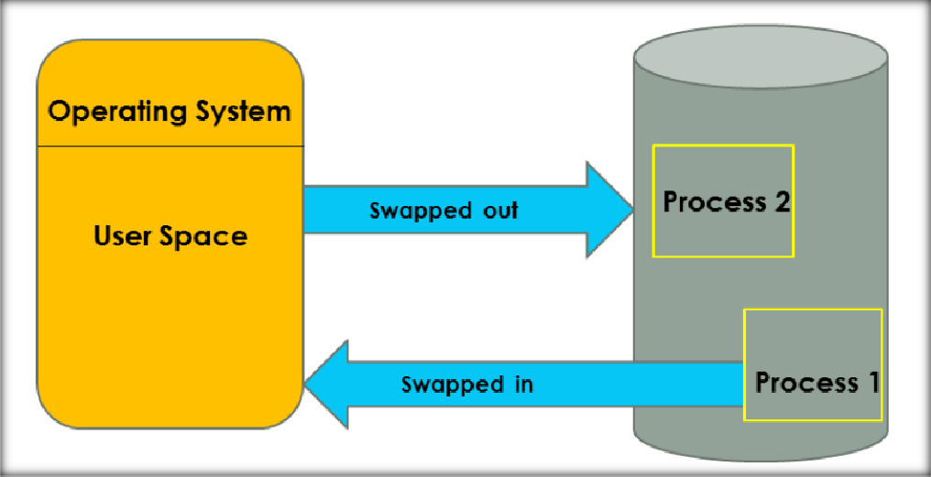

# Paging

Paging is the memory management technique in which secondary memory is divided into fixed-size blocks called pages, and main memory is divided into fixed-size blocks called frames. The Frame has the same size as that of a Page. The processes are initially in secondary memory, from where the processes are shifted to main memory (RAM) when there is a requirement. Each process is mainly divided into parts where the size of each part is the same as the page size. One page of a process is mainly stored in one of the memory frames. Paging follows no contiguous memory allocation. That means pages in the main memory can be stored at different locations in the memory.

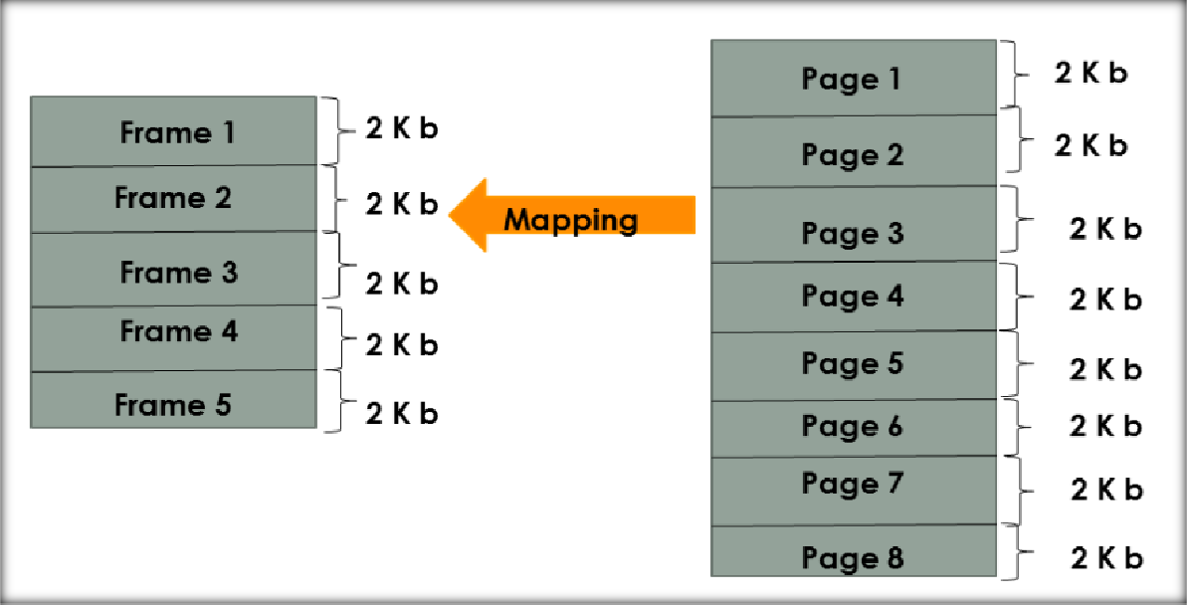

# Compaction

Compaction is a memory management technique in which the free space of a running system is compacted, to reduce fragmentation problem and improve memory allocation efficiency. Compaction is used by many modern operating systems, such as Windows, Linux, and Mac OS X. As in the fig we have some used memory(black color) and some unused memory(white color).The used memory is combined. All the empty spaces are combined together. This process is called compaction. This is done to prevent to solve the problem of fragmentation, but it requires too much of CPU time. By compacting memory, the operating system can reduce or eliminate fragmentation and make it easier for programs to allocate and use memory.

The compaction process usually consists of two steps:

* Copying all pages that are not in use to one large contiguous area.
* Then write the pages that are in use into the newly freed space.

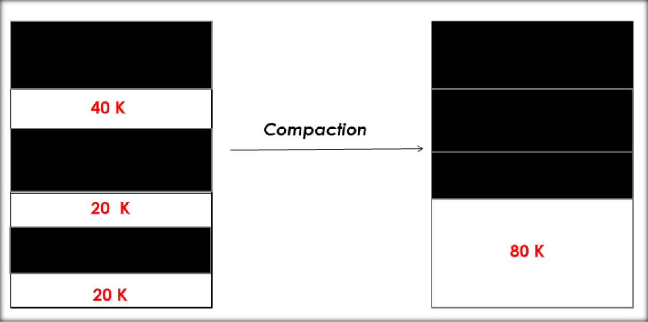

# Segmentation

Segmentation is another memory management technique used by operating systems. The process is divided into segments of different sizes and then put in the main memory. The program/process is divided into modules, unlike paging, in which the process was divided into fixed-size pages or frames. The corresponding segments are loaded into the main memory when the process is executed. Segments contain the program’s utility functions, main function, and so on.

